Game Engine Design: Assignment 1

Ioquake3 Python bot

Program listing:

-Quake 3 Arena

Changes/Improvements made:

This assignment involved editing a bot to perform various things when added into the game to do a lot of these tasks it involved passing data between client and server side. There are many changes that can be made to the quake python bot to make it perform various different tasks. Below are a few I have added into my python bot and explanations of how they were added into the game.

Added Health:

The health function for the bot was added to display the bots current health in the command line and update the int as the bots health changed. To start with an integer had to be exchanged between the client and the server side as shown in the code below:

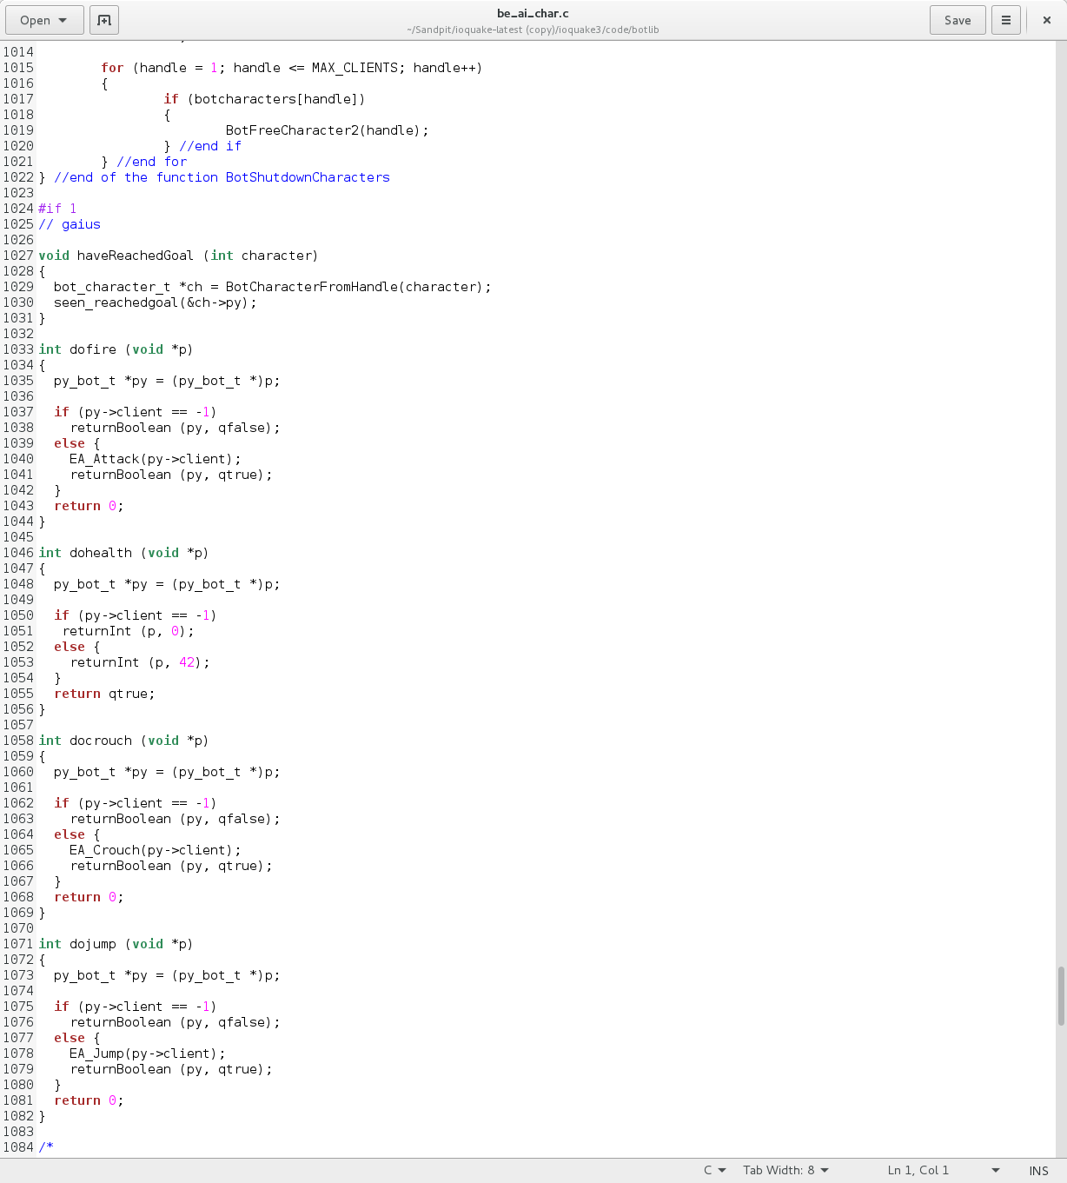

This initial version of the do health code will return the integer 42 to be displayed in the command line window.

This code then had to be changed in order to display the actual health of the bot this updated code is shown below.

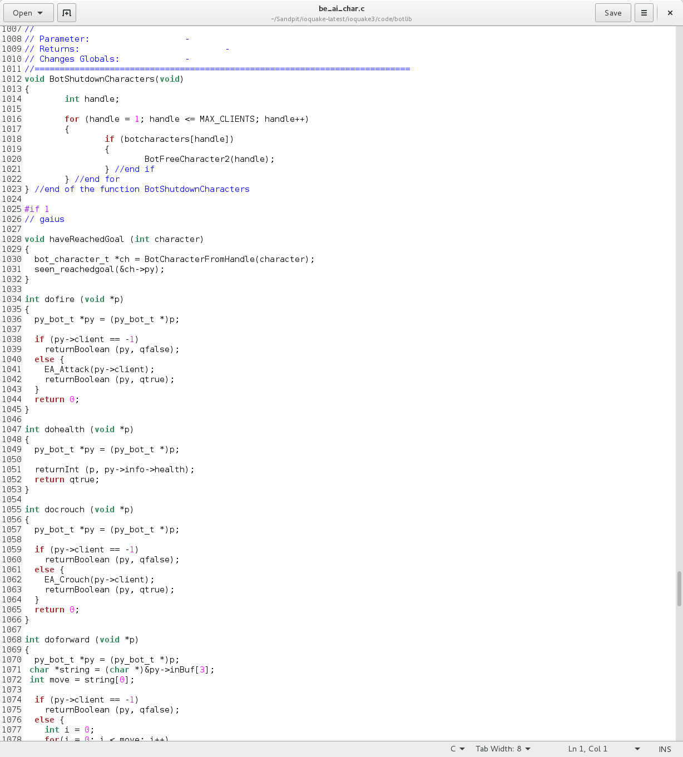

Move code:

The code that is required in order to make the bot move different directions is split into 4 functions, 1 for each direction forward, backward, left and right. This code also requires certain parts of the code to be placed in order to avoid confusion once it is called during runtime.

Added Move Forward:

The move forward function had to be added in order to enable the bot to make a step forward. To add this function various different files had to be altered and code had to be added in order for the bot to make just 1 step forward the code that was changed and added is shown below:

legoman.py – the code in Legoman executes the code in order to make the bot move this will run on a loop until the bot has either been removed or the application has been terminated

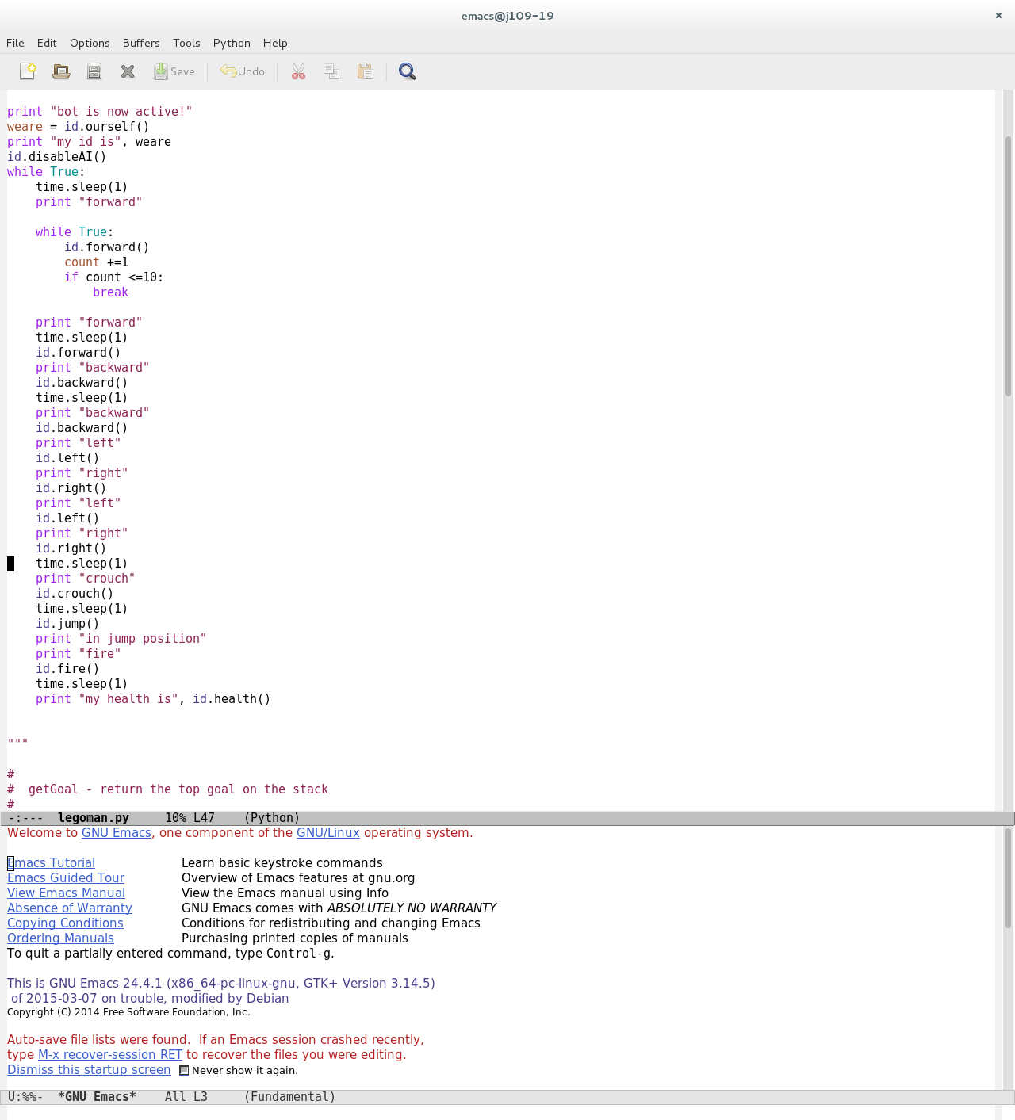

botlib.py – The botlib file includes a list of the basic nodes which must stay in the same order throughout the code as well as including the definition for the function that will return the values necessary for performing that function in this case moving forward

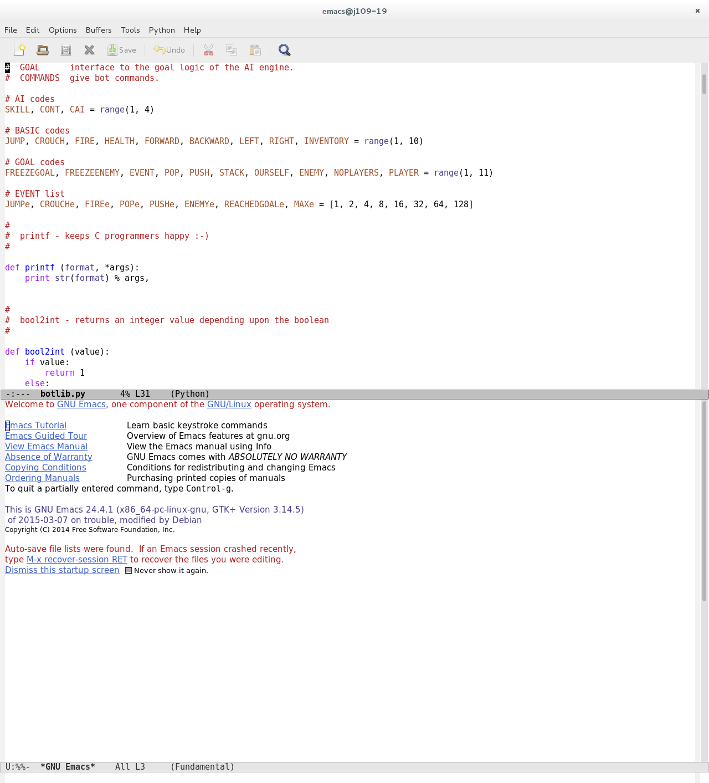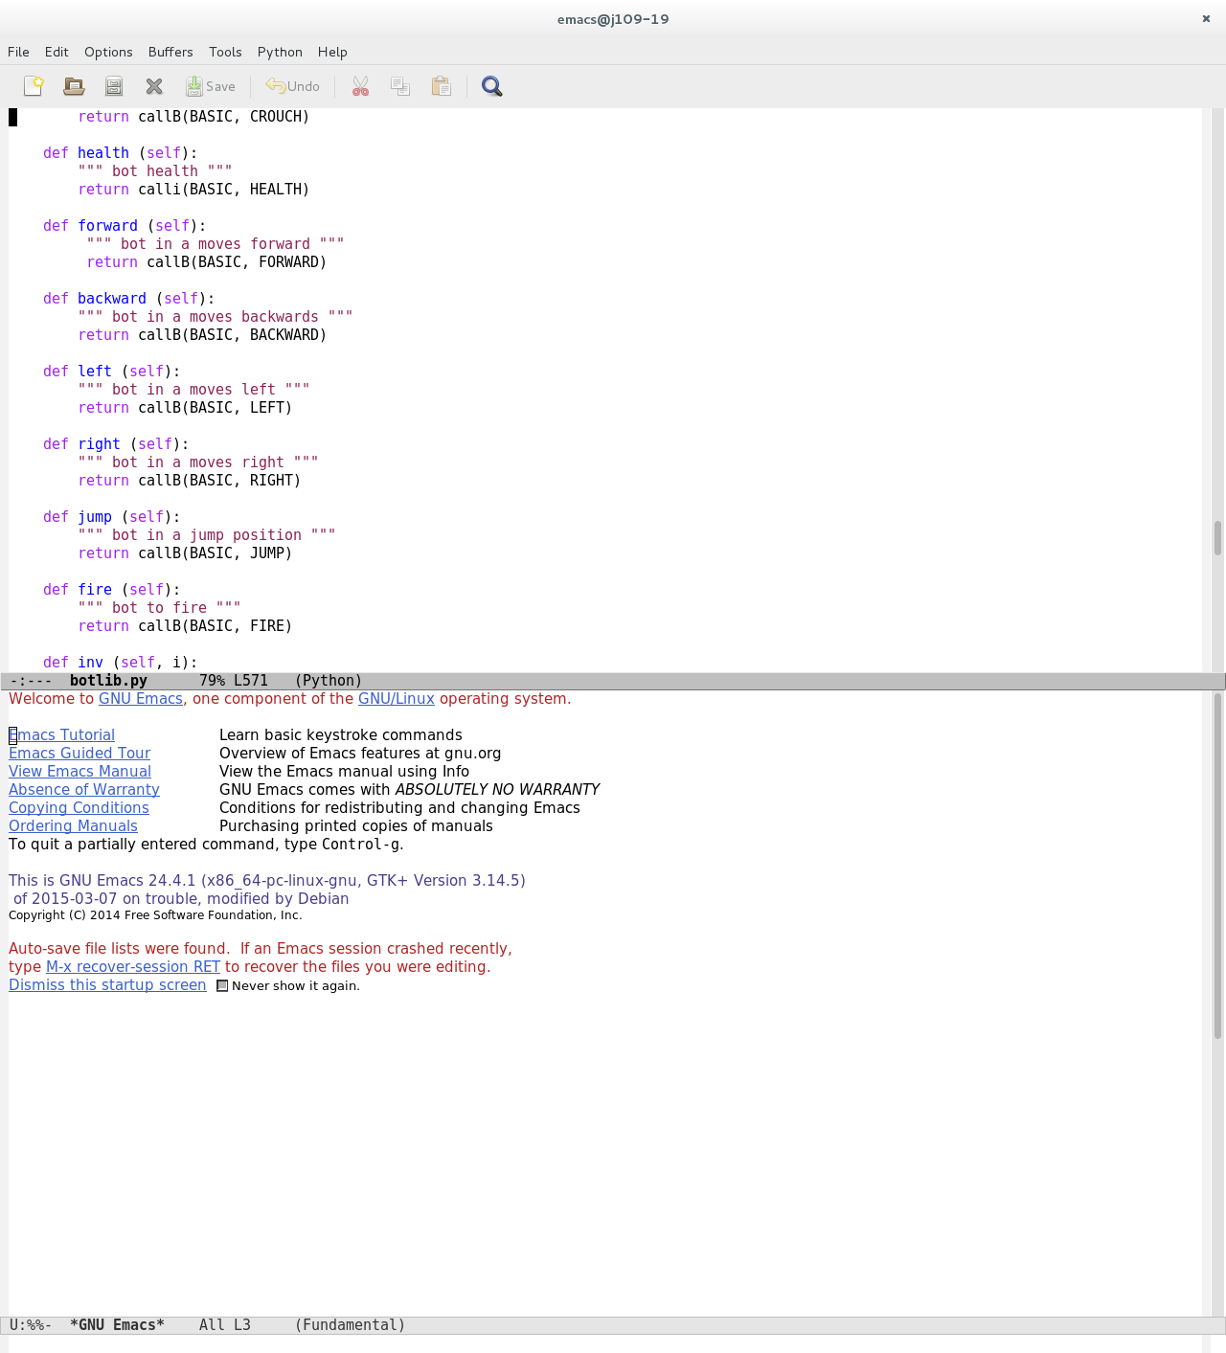

be_ai_char.c – The char.c file has been changed to include the doforward function which uses an existing EA function in another file called EA_MoveForward this function runs code that allows a step forward

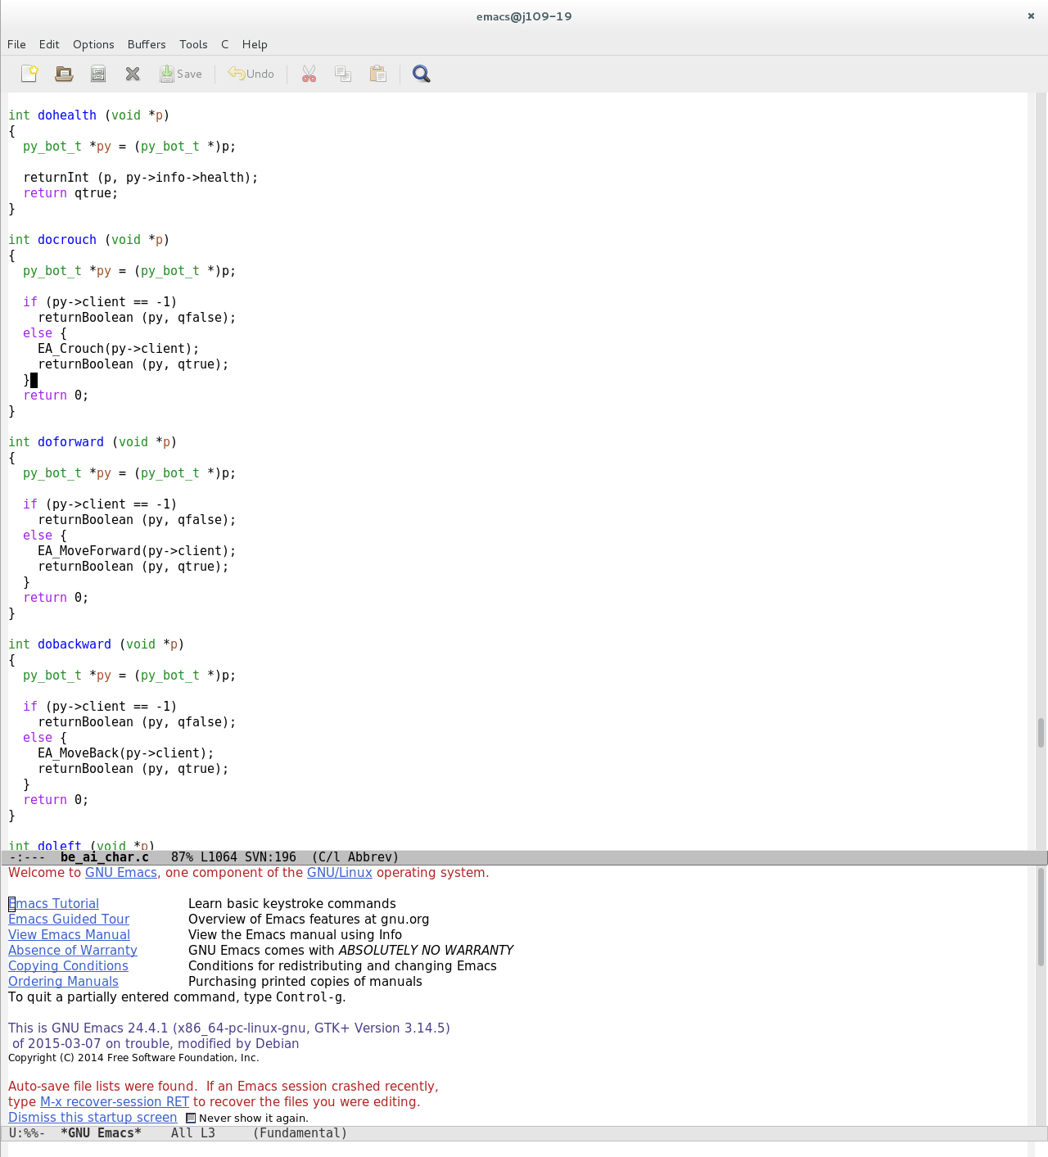

be_ai_py.c – This file needed to have the extra basic methods added into it in order for it to copy variables over to py versions

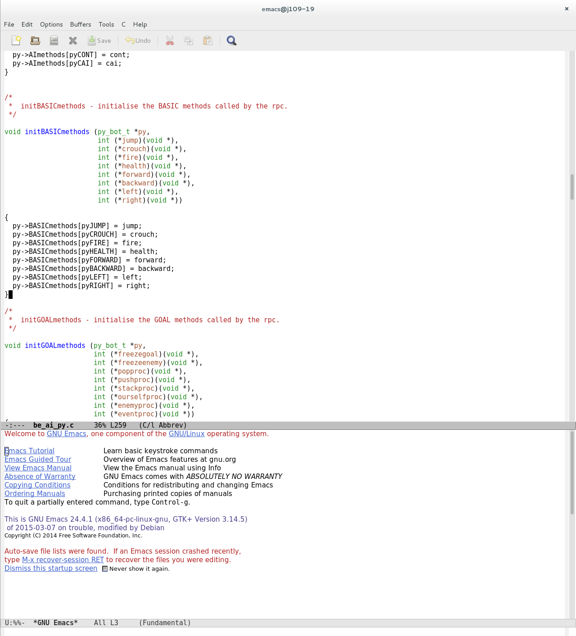

be_ai_py.h – The header file stores the External variables for the basic methods which must be defined in the same order again each time to avoid complications

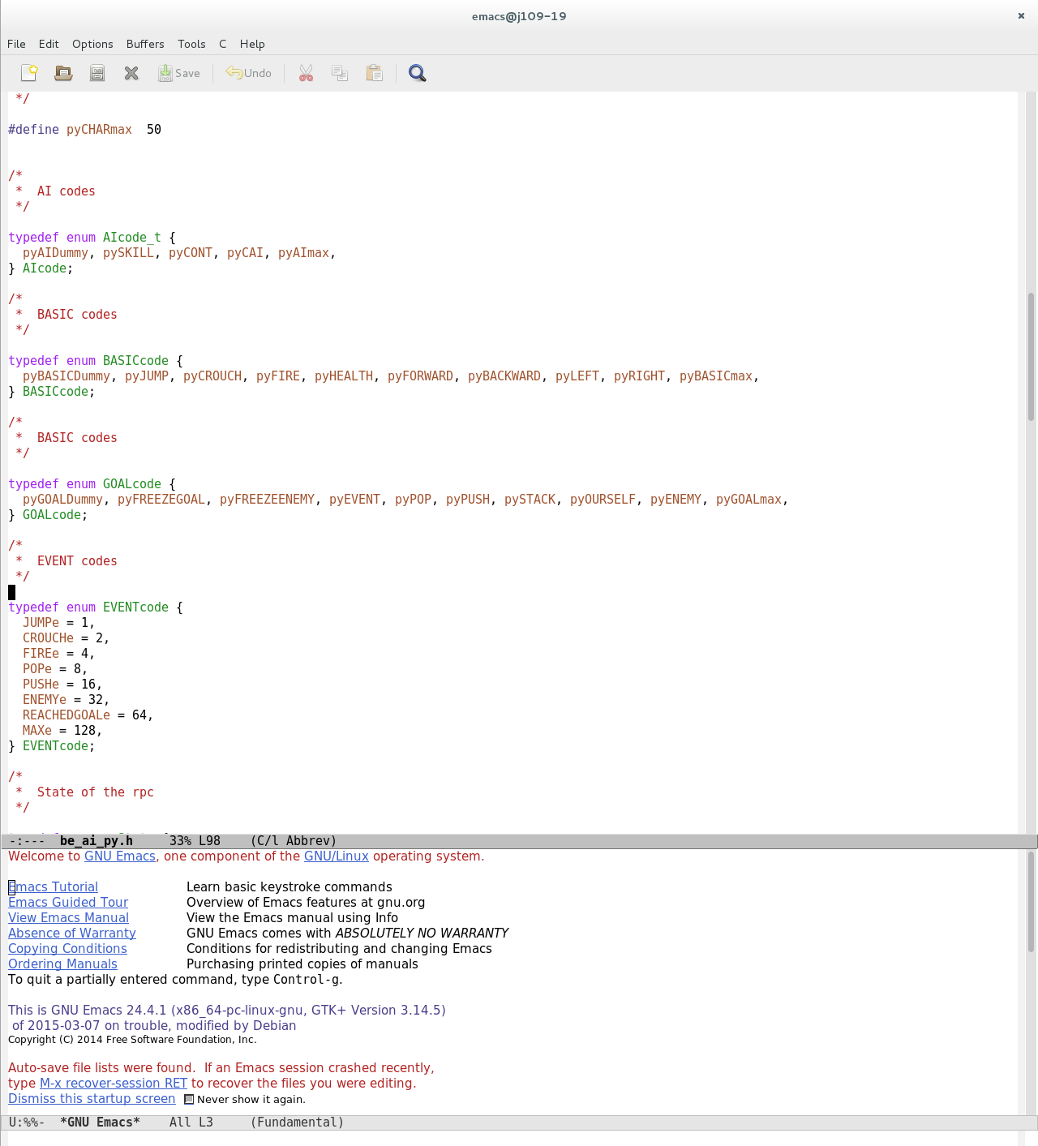

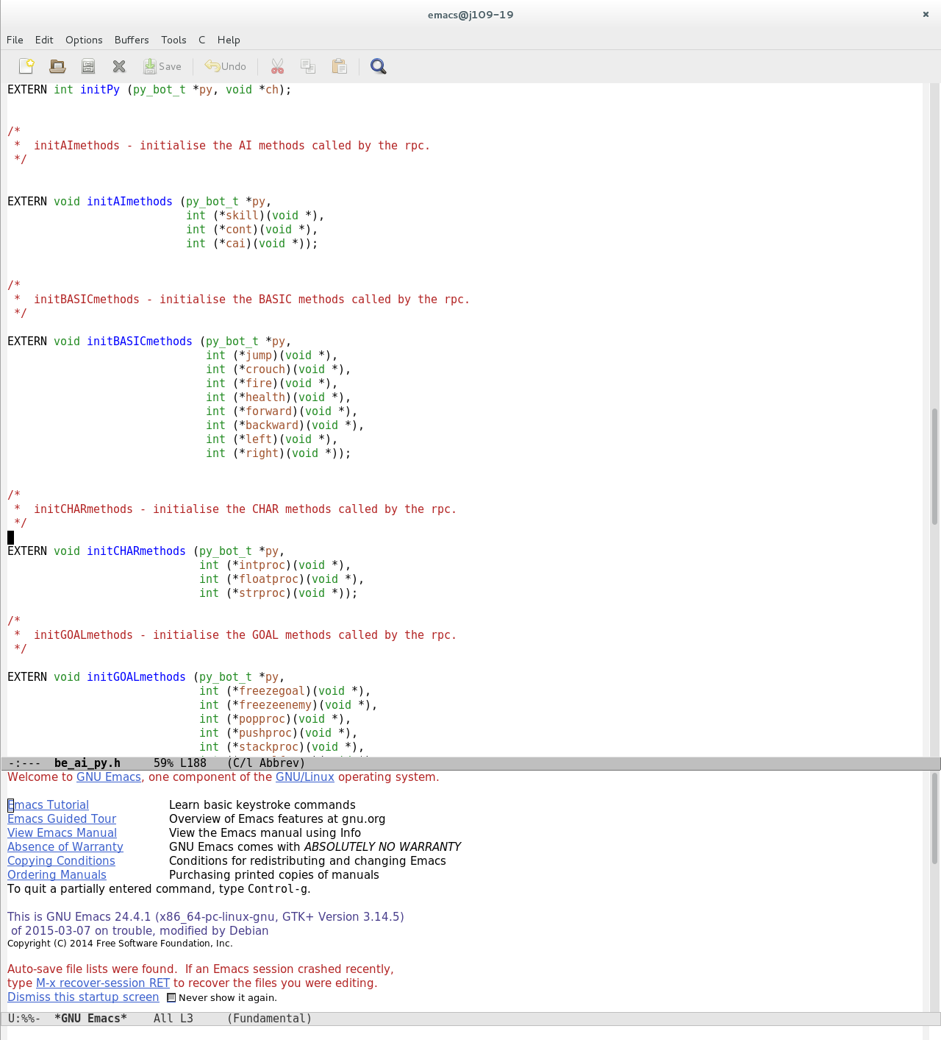

Forward extended code:

The Extended code of forward allows the bot to move forward multiple times with one call of id.forward() this code is shown below:

The (2) will be used in the for loop in the extended forward function in order to determine how many times the forward function will be run and make the bot move forward 2 steps instead of 1.

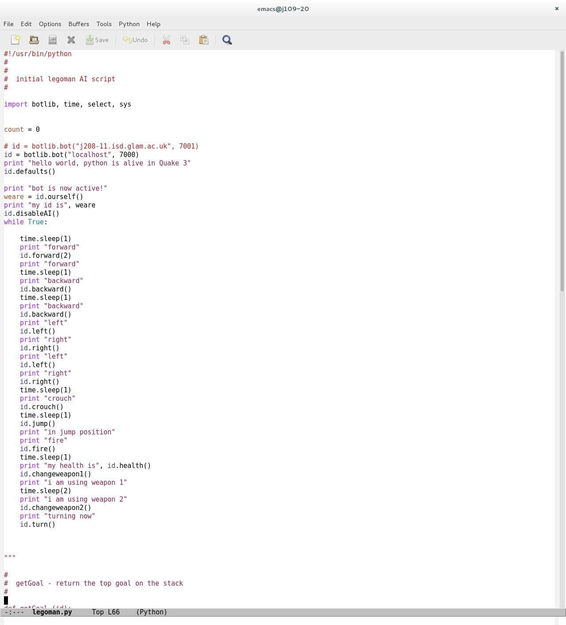

Updated forward

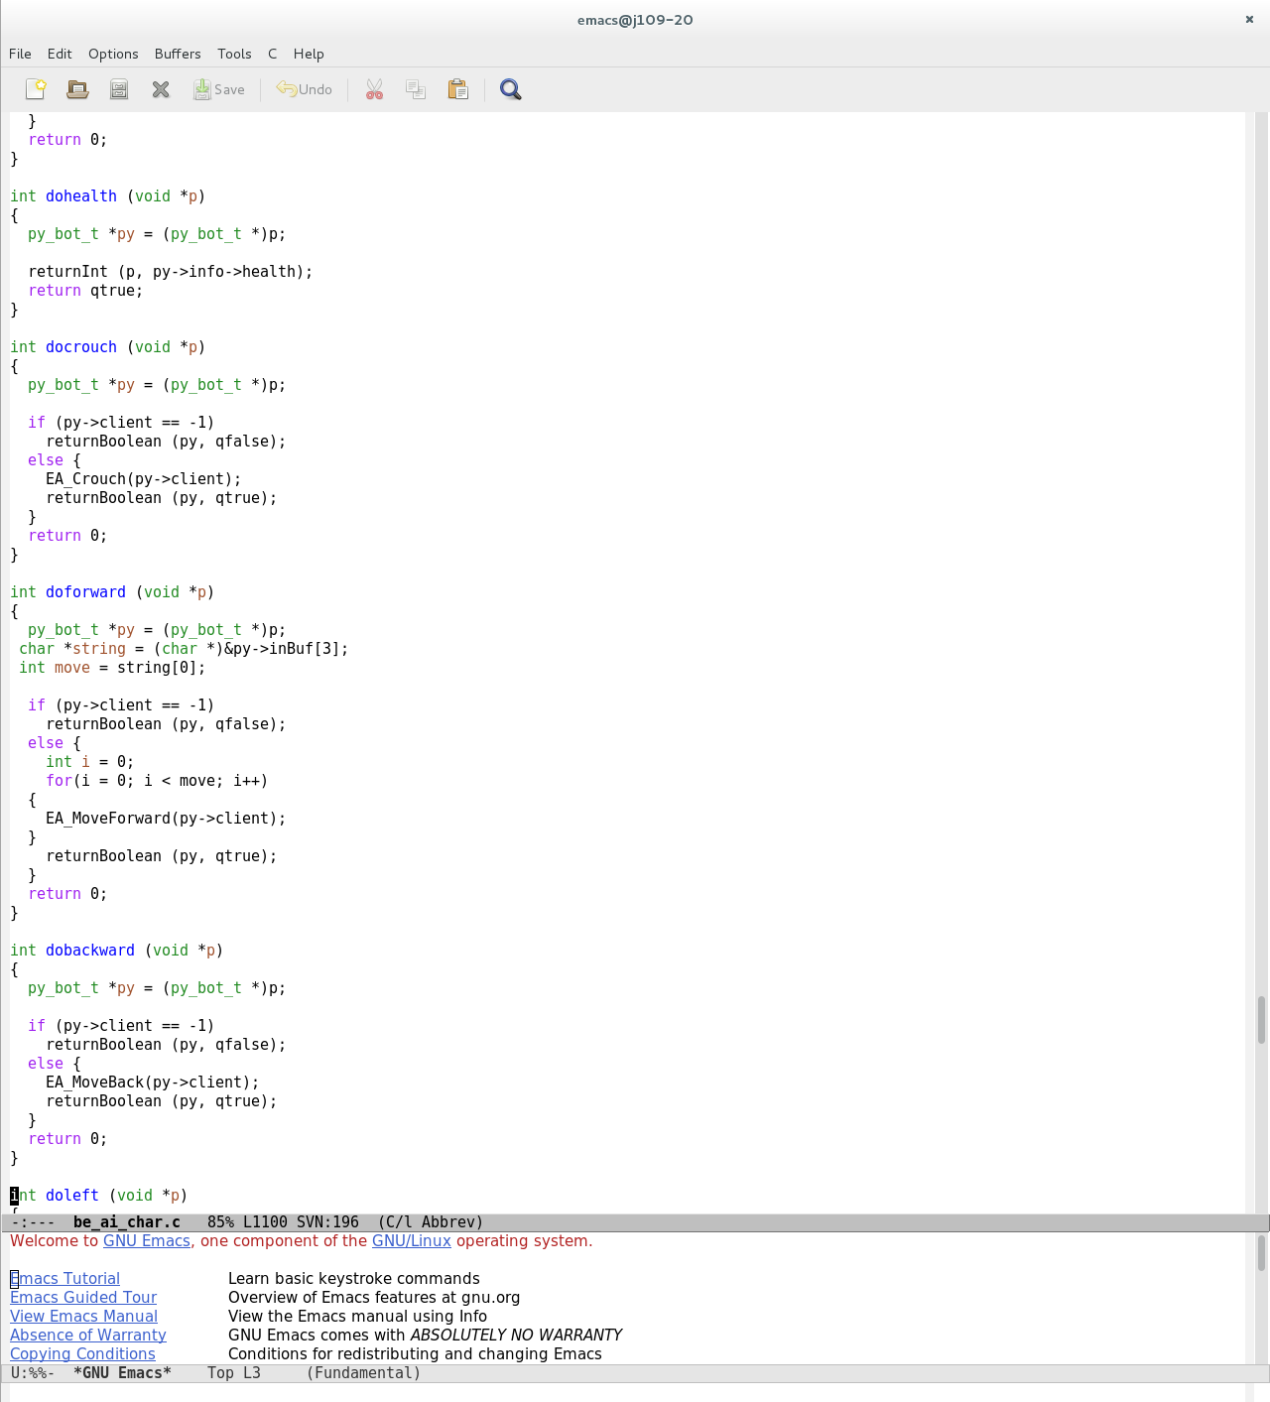

Added Move Left:

The move left function had to be added in order to enable the bot to make a step to the left. To add this function various different files had to be altered and code had to be added in order for the bot to make just 1 step left the code that was changed and added is shown below:

legoman.py - the code in Legoman executes the code in order to make the bot move this will run on a loop until the bot has either been removed or the application has been terminated



botlib.py - The botlib file includes a list of the basic nodes which must stay in the same order throughout the code as well as including the definition for the function that will return the values necessary for performing that function in this case moving left



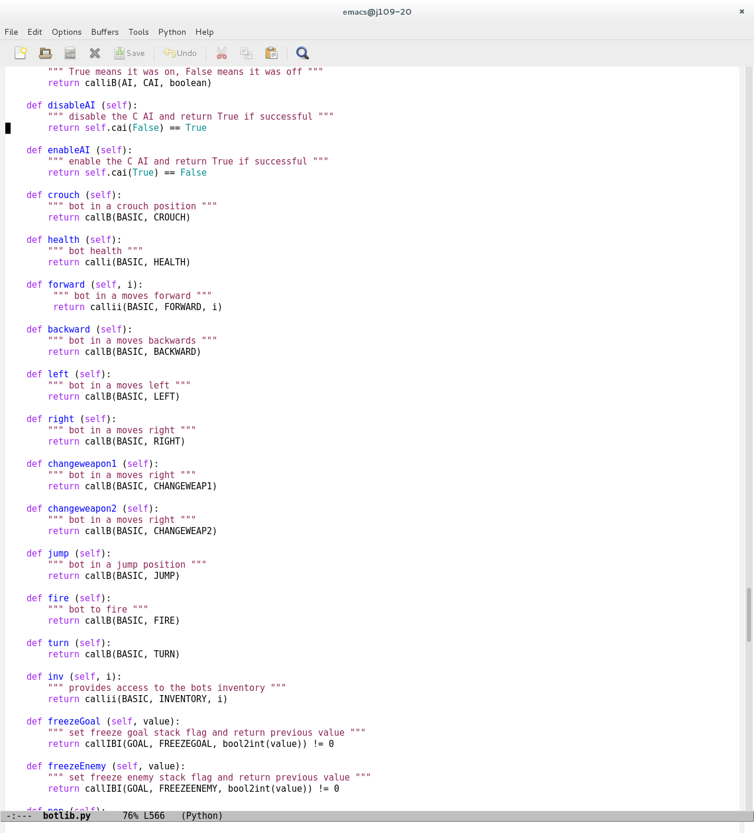

be_ai_char.c - The char.c file has been changed to include the doleft function which uses an existing EA function in another file called EA_MoveLeft this function runs code that allows a step to the left

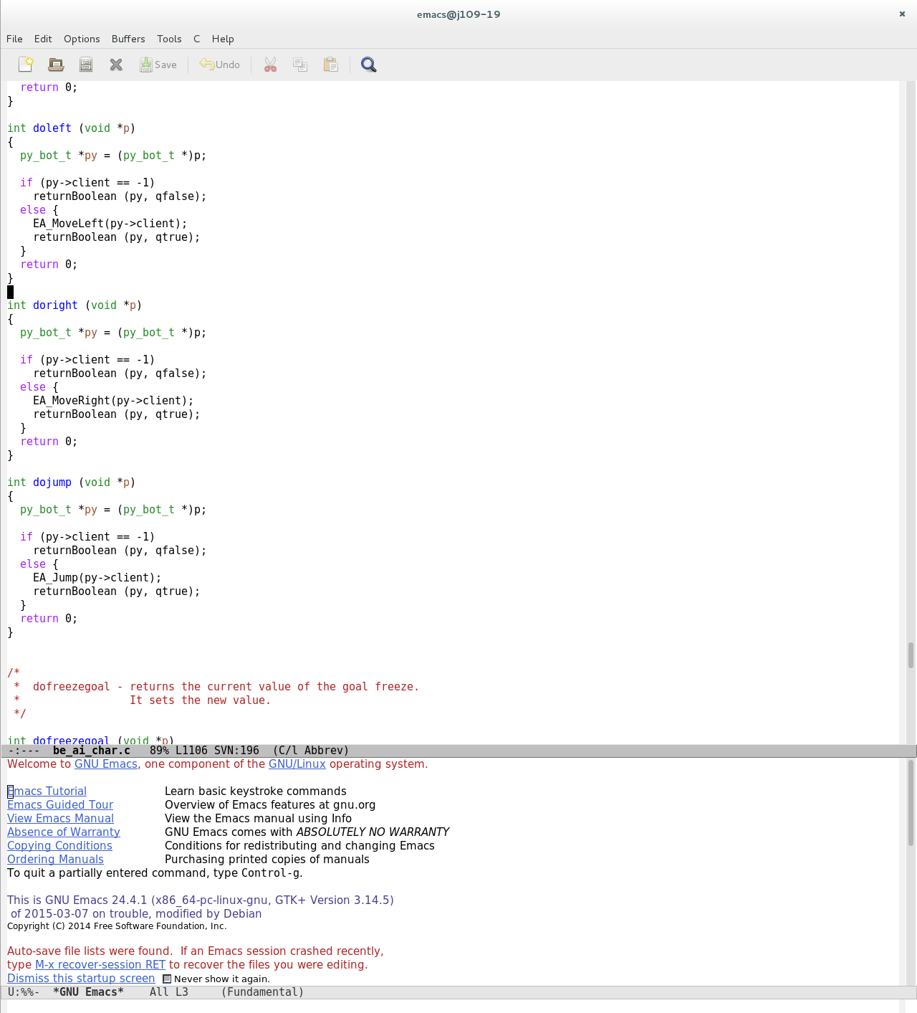

be_ai_py.c – This file needed to have the extra basic methods added into it in order for it to copy variables over to py versions



be_ai_py.h – The header file stores the External variables for the basic methods which must be defined in the same order again each time to avoid complications



Added Move Right:

The move right function had to be added in order to enable the bot to make a step to the right. To add this function various different files had to be altered and code had to be added in order for the bot to make just 1 step right the code that was changed and added is shown below:

legoman.py - the code in Legoman executes the code in order to make the bot move this will run on a loop until the bot has either been removed or the application has been terminated



botlib.py - The botlib file includes a list of the basic nodes which must stay in the same order throughout the code as well as including the definition for the function that will return the values necessary for performing that function in this case moving right





be_ai_char.c - The char.c file has been changed to include the doright function which uses an existing EA function in another file called EA_MoveRight this function runs code that allows a step to the right



be_ai_py.c – This file needed to have the extra basic methods added into it in order for it to copy variables over to py versions



be_ai_py.h – The header file stores the External variables for the basic methods which must be defined in the same order again each time to avoid complications



Added Move Backward:

The move backward function had to be added in order to enable the bot to make a step backward. To add this function various different files had to be altered and code had to be added in order for the bot to make just 1 step forward the code that was changed and added is shown below:

legoman.py - the code in Legoman executes the code in order to make the bot move this will run on a loop until the bot has either been removed or the application has been terminated



botlib.py - The botlib file includes a list of the basic nodes which must stay in the same order throughout the code as well as including the definition for the function that will return the values necessary for performing that function in this case moving backward



be_ai_char.c - The char.c file has been changed to include the dobackward function which uses an existing EA function in another file called EA_MoveBackward this function runs code that allows a step backwards



be_ai_py.c – This file needed to have the extra basic methods added into it in order for it to copy variables over to py versions



be_ai_py.h – The header file stores the External variables for the basic methods which must be defined in the same order again each time to avoid complications



Weapon Switching:

There are a number of ways of switching weapons using EA_SelectWeapon in the char file the simplest way however is to use EA_SelectWeapon to create multiple functions with a different weapon number in each one as shown in the code below:

legoman.py - the code in Legoman executes the code in order to make the bot swap between the weapon 0 (the knuckles) in the changeweapon1 and weapon 1(the machine gun) in the changeweapon2 function and this will run on a loop until the bot has either been removed or the application has been terminated



botlib.py - The botlib file includes a list of the basic nodes which must stay in the same order throughout the code as well as including the definition for the function that will return the values necessary for performing that function in this case switching weapons

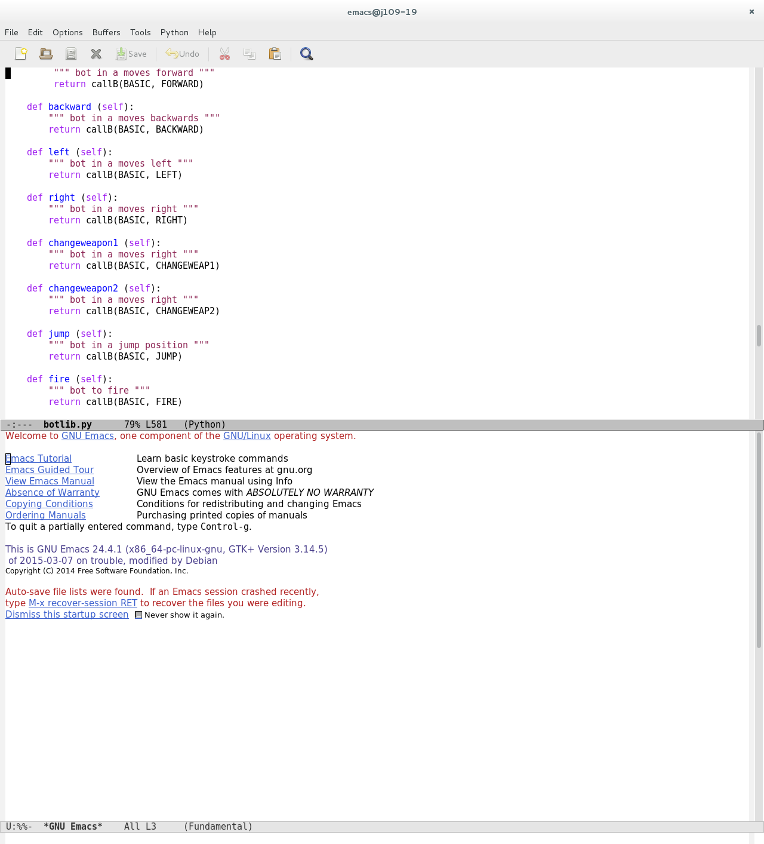

be_ai_char.c – The char.c file has been changed to include the dochangeweapon1 and dochangeweapon2 functions. Which uses an existing EA function in another file called EA_SelectWeapon this function requires 2 arguments. The selection of the client and the number of the weapon that you wish to select each weapon is assigned a number of 1 to 9 this includes all standard weapons any extras would add to this number.

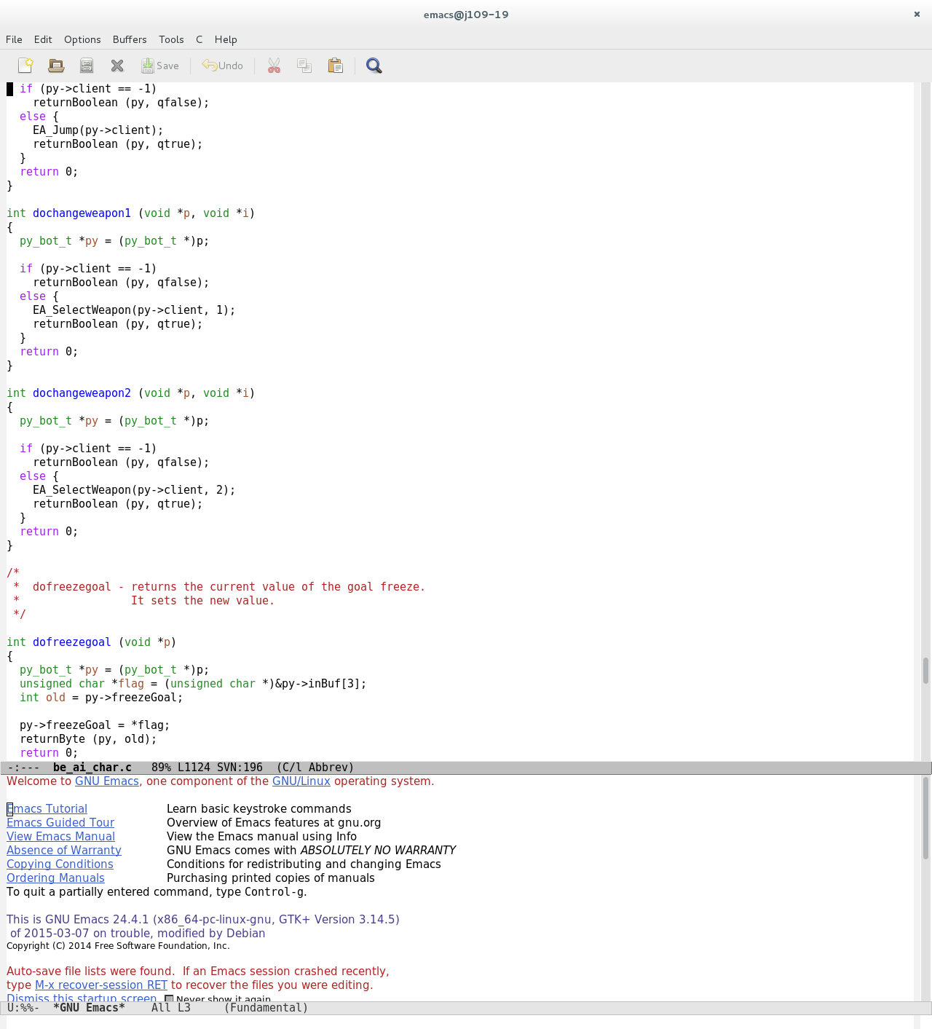

be_ai_py.c – This file needed to have the extra basic methods added into it in order for it to copy variables over to py versions

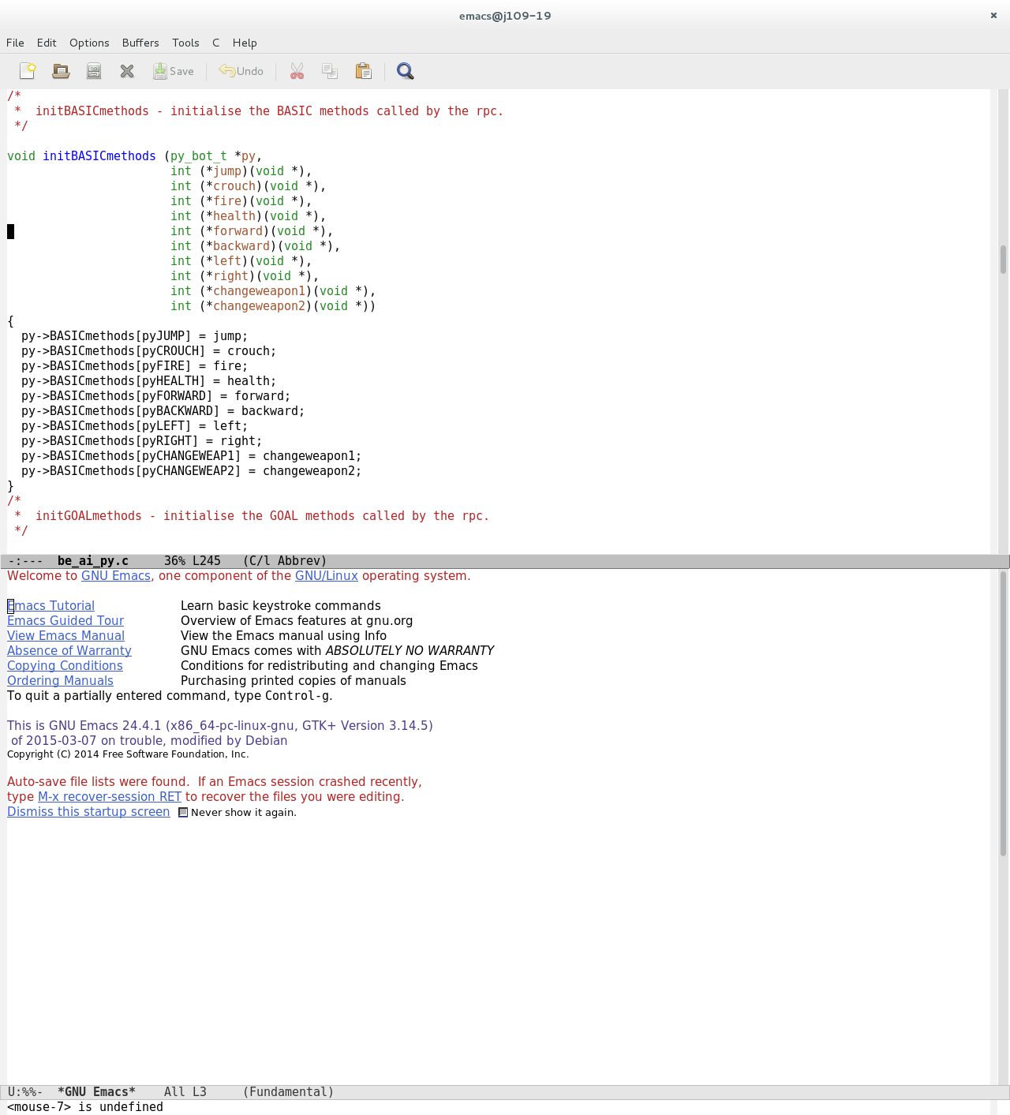

be_ai_py.h – The header file stores the External variables for the basic methods which must be defined in the same order again each time to avoid complications

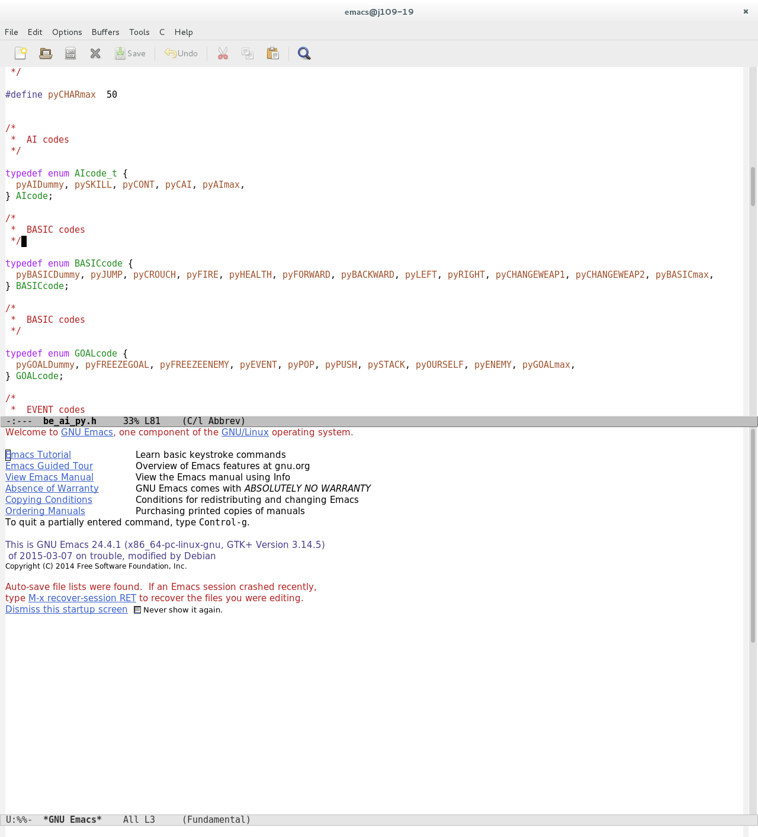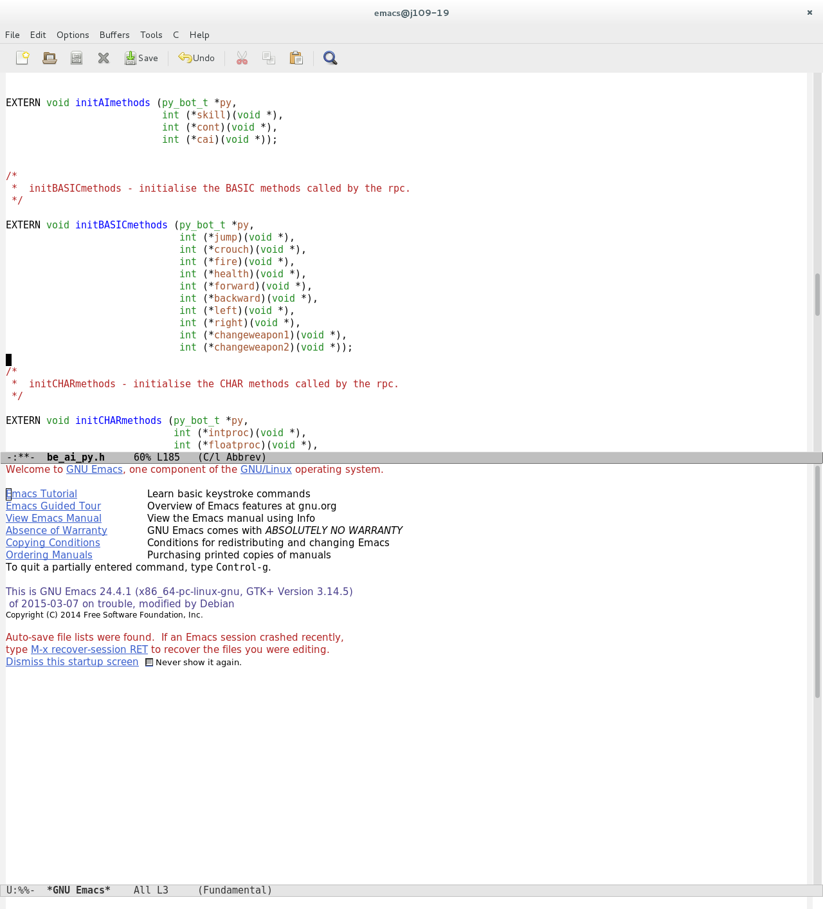

A more complicated way of swapping weapons which reduces the code used to swap weapons involves giving the bot all weapons from the beginning and using a for loop to switch between each weapon number by passing a number back and for between the client and server side code.

Turning:

To make the bot turn a new EA function has to be added into the be_ea.c and .h files as well as editing another EA function to update and change the viewing angles of the bot. This code then needs to be activated in a function and called in the legomans file in order to run.

legoman.py - the code in Legoman executes the code in order to make the bot spin this will run on a loop until the bot has either been removed or the application has been terminated. The first activation of this code will make the bot start spinning the second activation will stop it.



botlib.py - The botlib file includes a list of the basic nodes which must stay in the same order throughout the code as well as including the definition for the function that will return the values necessary for performing that function in this case spinning the bot around



be_ai_char.c – This file had to be changed to add in a doturn function which calls the EA_AddView function I created in be_ea.c to edit the grabbed variables from the python bot.

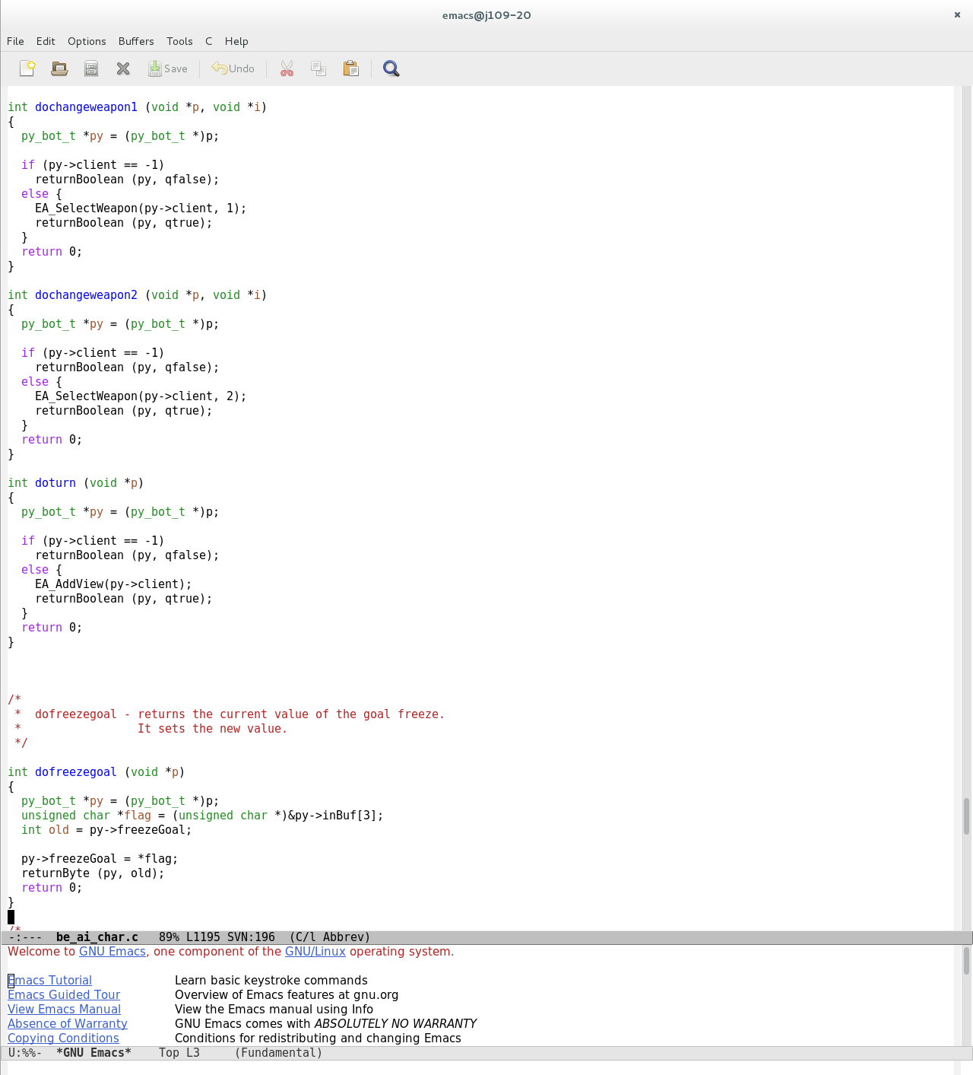

be_ai_py.c – This file needed to have the extra basic methods added into it in order for it to copy variables over to py versions

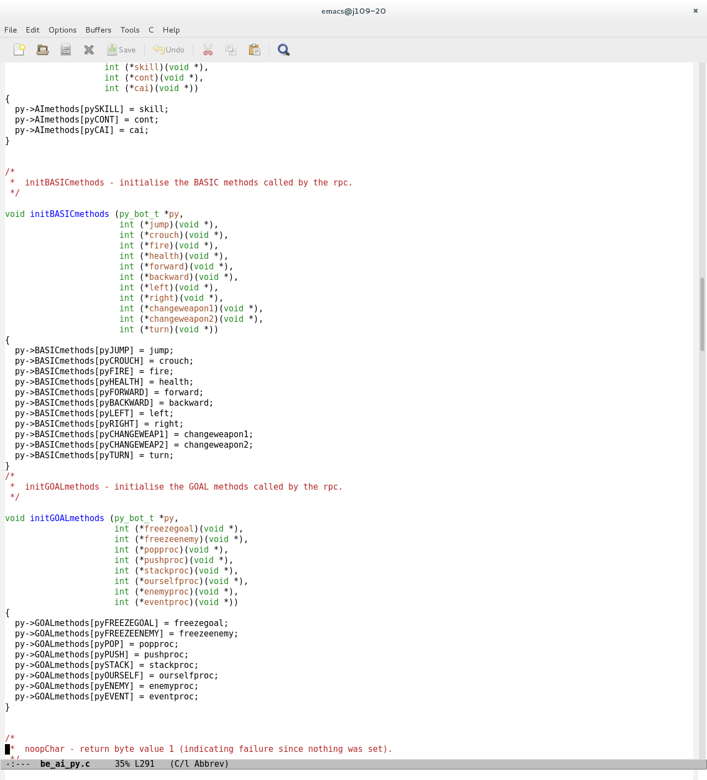

be_ai_py.h – The header file stores the External variables for the basic methods which must be defined in the same order again each time to avoid complications

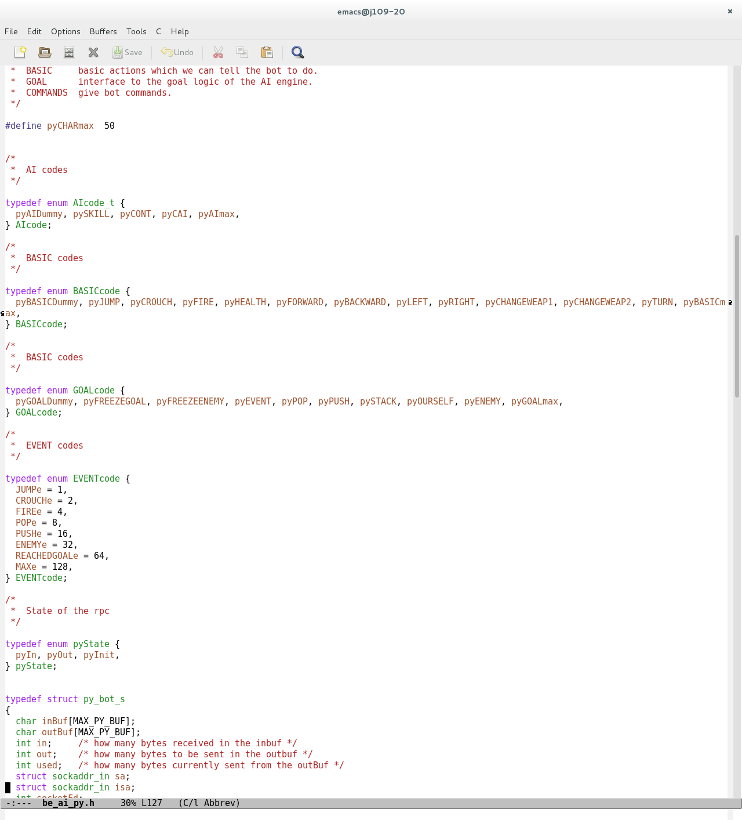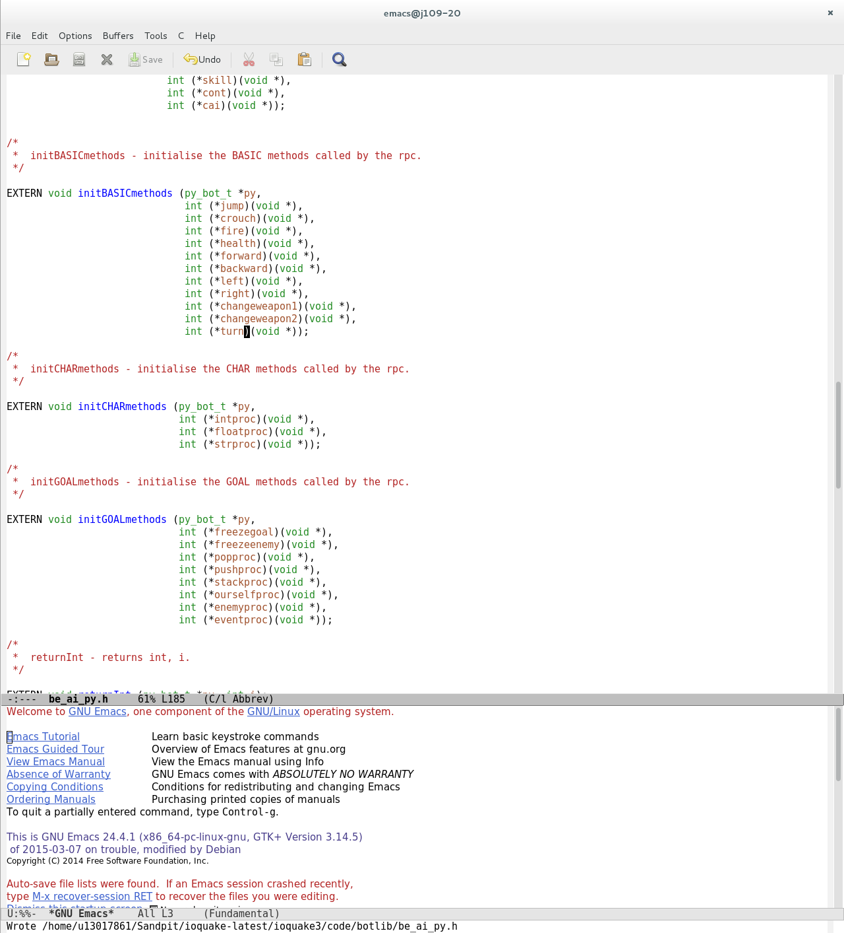

be_ea.c - In this file I have edited EA_View and added a new EA_ called EA_AddView. Firs t Anglechange is created outside the functions to be used in both then in EA_View it is used to get the view angles of the bot and add the amount that you want to change the angles by to the existing angles and update them. The EA_AddView changes the amount added onto the viewangles with anglechange the result causes the bot to spin.

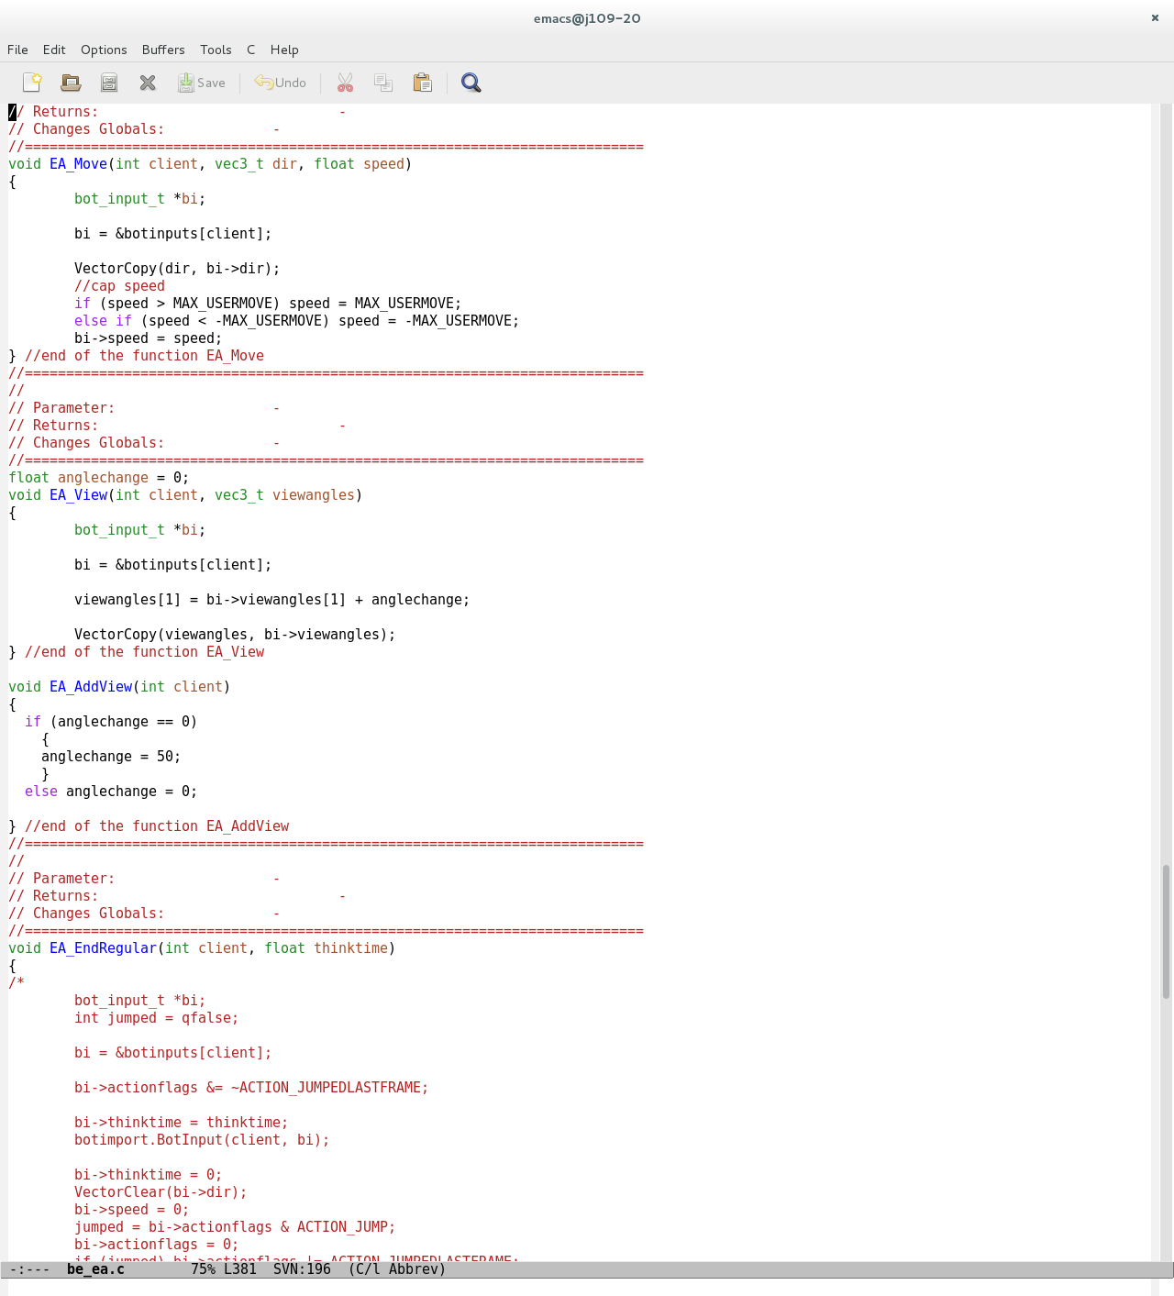

be_ea.h - The AddView needs to be added to the list on the header file so it can be called by the char.c file

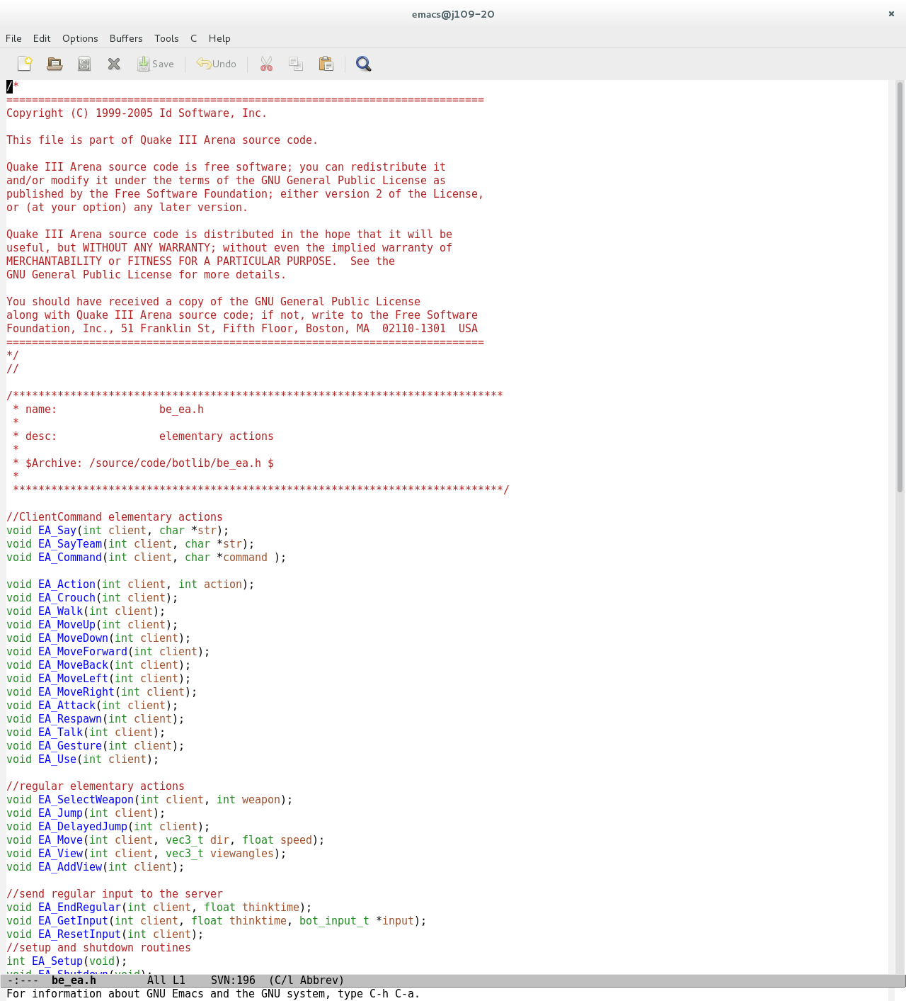

Possible changes:

There are multiple other changes that can be added to the bot to display various other ways of passing information between the server and the client some of these are discussed below.

Say:

Addition to the code can be added in order to make the bot say things when specific instances occur for instance when dying or when spawning this can be done by using EA_Say in order to pass a string between the client and server side code to be output by the bot in the game.

Getting the position of the bot:

Getting the position of the bot requires accessing the position integer variables in the server side code and passing them through to the client side for the bot to display the integers in the terminal.

Protocol Diagram:

Server Response:

The server runs the functions in the server then returns the values required and displays any it’s required to then moves onto the next function to be called.

Client request:

Botlib requests information stored in server side files and code.

Server

Client: botlib.py